Neighborhood Food Waste & Donation Distribution System
1. Introduction
This project aims to design and implement a database system that supports a real-world solution for food waste management. The system connects donors who have surplus edible food with NGOs and volunteers who distribute that food to families or individuals in need. The database ensures accurate tracking of food availability, expiration dates, donation requests, pickup routes, and delivery confirmations.

2. Domain Selection
The chosen domain is the Food Waste & Donation Management System, which operates within the fields of community service and social support.

3. Project Structure:

A. Domain Description
This domain focuses on organizing surplus food donations between multiple stakeholders. The purpose of the system is to reduce waste, improve distribution efficiency, and ensure food reaches recipients before expiration.
Stakeholders: Donor, Volunteer, Recipient, System Admin
Key Functionalities:
- Register donors, volunteers, and recipients.
- Store detailed information about food items and expiration.
- Approve or reject donation requests.
- Assign volunteers for collection and delivery.
- Confirm receipt of delivered items.

B. Information Gathering
Research was conducted on food waste statistics, donation workflow, and NGO operations. Primary challenges identified:
- No centralized tracking of surplus food.
- Difficulty matching donors to recipients in real time.
- Lack of traceability for deliveries and approvals.
- Need for expiry monitoring to avoid unsafe food distribution.

Identified Entities:
- Donor
- Food Item
- Donation Request
- Volunteer
- Recipient
- Delivery Record (weak entity)
Identified Relationships:
- Donor => Food Item (1-M)
- Food Item => Donation Request (1-M)
- Donation Request => Delivery Record (1-M) (weak)
- Volunteer => Delivery Record (1-M)
- Recipient => Delivery Record (1-M)

D. Objectives
Main Objectives
- Reduce food waste by matching donors with recipients.
- Create a reliable data structure for tracking donations.
- Support NGOs and volunteers with organized distribution.
Technical Objectives
- Design a relational database with integrity, constraints, and normalization.
- Implement entities, relationships, and weak/strong dependencies.
- Ensure data scalability and validation.
Expected Outcomes
- ERD diagram
- Normalized relational schema
- Conceptual and logical database model
- Organized donation lifecycle tracking system

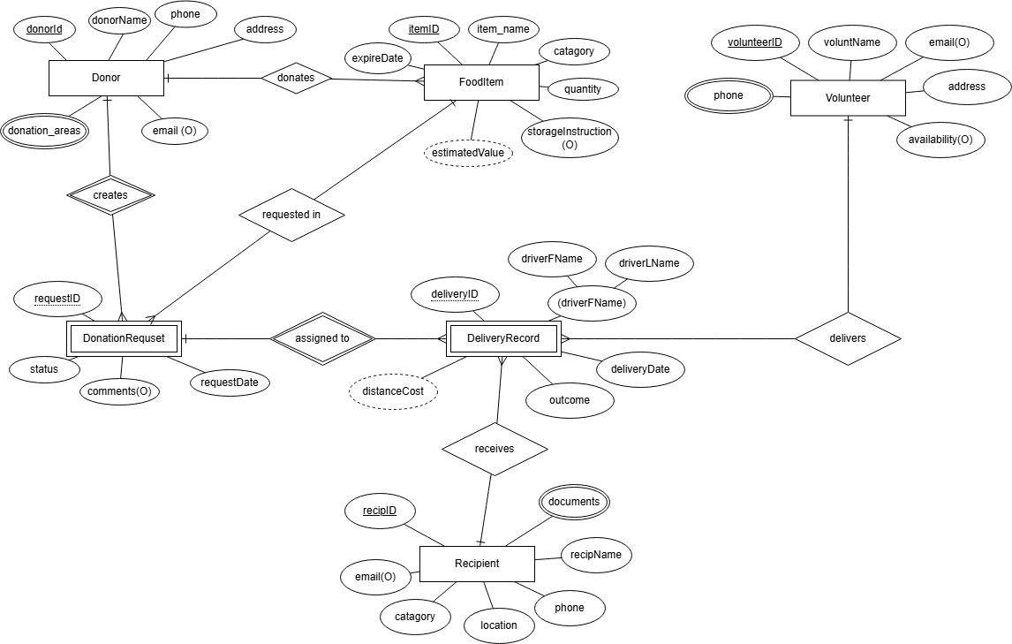
E. Entity-Relationship Diagram (ERD):

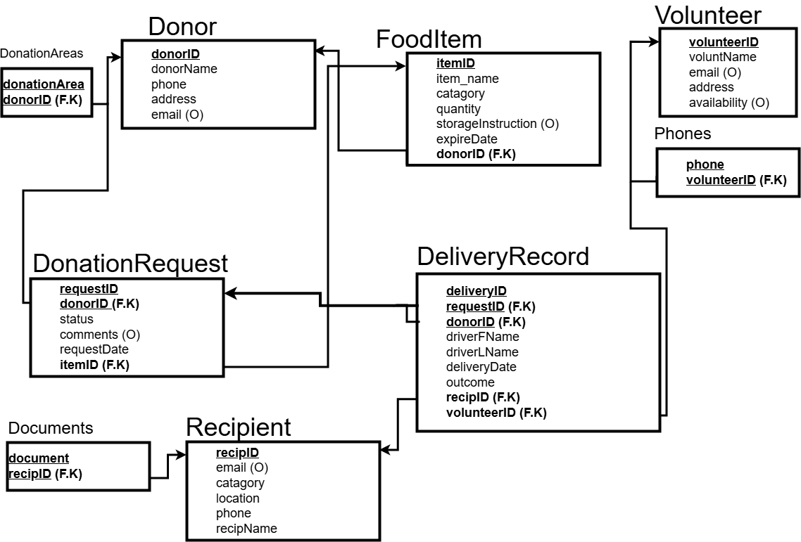
F. Database Schema Design:

SQL:
create schema food_donation_system;
CREATE TABLE Donor (
donorId NUMERIC(7) PRIMARY KEY,
donorName VARCHAR(100) NOT NULL,
phone VARCHAR(20) NOT NULL,
address VARCHAR(255) NOT NULL,
email VARCHAR(100)
);

CREATE TABLE DonationAreas (
donationArea VARCHAR(100),
donorId NUMERIC(7),
FOREIGN KEY (donorId) REFERENCES Donor(donorId),
PRIMARY KEY (donationArea, donorId)
);

CREATE TABLE FoodItem (
itemId NUMERIC(7) PRIMARY KEY,
itemName VARCHAR(100) NOT NULL,
category VARCHAR(50) NOT NULL,
quantity NUMERIC(7) NOT NULL,
storageInstruction varchar(255),
expiryDate TIMESTAMP NOT NULL,
donorId NUMERIC(7),
FOREIGN KEY (donorId) REFERENCES Donor(donorId)
);

CREATE TABLE DonationRequest (
requestId NUMERIC(7),
donorId NUMERIC(7),
status VARCHAR(20) NOT NULL,
comments varchar(255),
requestDate TIMESTAMP NOT NULL,
itemId NUMERIC(7),
FOREIGN KEY (donorId) REFERENCES Donor(donorId),
FOREIGN KEY (itemId) REFERENCES FoodItem(itemId),
PRIMARY KEY (requestId, donorId)
);

CREATE TABLE Recipient (
recipId NUMERIC(7) PRIMARY KEY,
recipName VARCHAR(100) NOT NULL,
email VARCHAR(100),
category VARCHAR(100) NOT NULL,
location VARCHAR(100) NOT NULL,
phone VARCHAR(20) NOT NULL
);

CREATE TABLE Documents (
document VARCHAR(100),
recipId NUMERIC(7),
FOREIGN KEY (recipId) REFERENCES Recipient(recipId),
PRIMARY KEY (document, recipId)
);

CREATE TABLE Volunteer (
volunteerId NUMERIC(7) PRIMARY KEY,
voluntName VARCHAR(100) NOT NULL,
email VARCHAR(100),
address VARCHAR(255) NOT NULL,
availability VARCHAR(255)
);

CREATE TABLE Phones (
phone VARCHAR(20),
volunteerId NUMERIC(7),
FOREIGN KEY (volunteerId) REFERENCES Volunteer(volunteerId),
PRIMARY KEY (phone, volunteerId)
);

CREATE TABLE DeliveryRecord (
deliveryId NUMERIC(7),
requestId NUMERIC(7),
donorId NUMERIC(7),
driverFName VARCHAR(100) NOT NULL,
driverLName VARCHAR(100) NOT NULL,
deliveryDate TIMESTAMP NOT NULL,
outcome VARCHAR(50) NOT NULL,
recipId NUMERIC(7),
volunteerId NUMERIC(7),
FOREIGN KEY (requestId, donorId) REFERENCES DonationRequest(requestId, donorId),
FOREIGN KEY (recipId) REFERENCES Recipient(recipId),
FOREIGN KEY (volunteerId) REFERENCES Volunteer(volunteerId),
PRIMARY KEY (deliveryId, requestId, donorId)
);
Insert:
INSERT INTO Donor (donorId, donorName, phone, address, email) VALUES
(1, 'City Mall', '0791234567', '123 Main St, Amman', 'contact@citymall.com'),
(2, 'Mecca Mall', '0797654321', '456 King St, Amman', 'info@meccamall.com'),
(3, 'Safeway Supermarket', '0795551234', '789 Queen Ave, Irbid', 'support@safeway.com'),
(4, 'Sameh Mall', '0796667890', '321 Palace Rd, Amman', 'donations@samehmall.com'),
(5, 'Taj Mall', '0798889999', '654 Commercial St, Amman', 'manager@tajmall.com'),
(6, 'Carrefour Jordan', '0792223344', '111 Garden Blvd, Zarqa', 'info@carrefour.jo');

INSERT INTO DonationAreas (donationArea, donorId) VALUES
('Amman - Abdali', 1),
('Amman - Sweifieh', 1),
('Amman - Mecca St', 2),
('Irbid - Downtown', 3),
('Amman - Shmeisani', 4),
('Amman - Jabal Amman', 4),
('Amman - Abdoun', 5),
('Zarqa - City Center', 6);

INSERT INTO FoodItem (itemId, itemName, category, quantity, storageInstruction, expiryDate, donorId) VALUES
(1, 'Bread', 'Bakery', 50, 'Keep in cool dry place', '2026-01-05 18:00:00', 1),
(2, 'Rice', 'Prepared Food', 20, 'Refrigerate immediately', '2026-01-03 12:00:00', 2),
(3, 'Canned Beans', 'Canned Goods', 100, 'Store at room temperature', '2027-06-15 00:00:00', 3),
(4, 'Apples', 'Produce', 30, 'Keep refrigerated', '2026-01-08 00:00:00', 3),
(5, 'Sandwiches', 'Prepared Food', 25, 'Keep frozen', '2026-01-10 00:00:00', 4),
(6, 'Milk', 'Dairy', 40, 'Refrigerate at 4°C', '2026-01-06 00:00:00', 5),
(7, 'Pasta', 'Dry Goods', 80, 'Store in dry place', '2027-12-31 00:00:00', 6),
(8, 'Cheese', 'Dairy', 15, 'Keep refrigerated', '2026-01-15 00:00:00', 2);
INSERT INTO DonationRequest (requestId, donorId, status, comments, requestDate, itemId) VALUES
(1, 1, 'Approved', 'Urgent - expires soon', '2026-01-01 09:00:00', 1),
(2, 2, 'Pending', 'Available for pickup tomorrow', '2026-01-01 10:30:00', 2),
(3, 3, 'Approved', 'Large donation - needs truck', '2026-01-01 11:00:00', 3),
(4, 3, 'Completed', 'Successfully delivered', '2025-12-30 14:00:00', 4),
(5, 4, 'Approved', 'Frozen meals ready', '2026-01-01 08:00:00', 5),
(6, 5, 'Rejected', 'Expired items included', '2025-12-29 16:00:00', 6),
(7, 6, 'Approved', 'Dry goods - long shelf life', '2026-01-01 13:00:00', 7);

INSERT INTO Recipient (recipId, recipName, email, category, location, phone) VALUES
(1, 'Hope Community Center', 'info@hopecenter.org', 'NGO', 'Amman - Jabal Hussein', '0791111111'),
(2, 'Caring Hearts Foundation', 'contact@caringhearts.org', 'NGO', 'Zarqa - East District', '0792222222'),
(3, 'Ahmad Family', 'ahmad.family@email.com', 'Individual', 'Irbid - North Area', '0793333333'),
(4, 'Children Shelter', 'admin@childrenshelter.org', 'Shelter', 'Amman - Marka', '0794444444'),
(5, 'Refugee Center', 'help@refugeecenter.org', 'NGO', 'Aqaba - Downtown', '0795555555'),
(6, 'Elderly Care Home', 'info@elderlycare.org', 'Care Home', 'Madaba - City Center', '0796666666');

INSERT INTO Documents (document, recipId) VALUES
('Registration Certificate', 1),
('Tax Exemption Letter', 1),
('NGO License 2025', 2),
('Identity Verification', 3),
('Facility License', 4),
('Government Approval', 4),
('UNHCR Registration', 5),
('Health Permit', 6);

INSERT INTO Volunteer (volunteerId, voluntName, email, address, availability) VALUES
(1, 'Mohammed Ali', 'mohammed.ali@email.com', '100 Main St, Amman', 'Monday-Friday 9AM-5PM'),
(2, 'Sara Ahmed', 'sara.ahmed@email.com', '200 Second St, Zarqa', 'Weekends only'),
(3, 'Khaled Hassan', 'khaled.h@email.com', '300 Third Ave, Irbid', 'Monday, Wednesday, Friday'),
(4, 'Layla Ibrahim', 'layla.ib@email.com', '400 Fourth Rd, Amman', 'Tuesday-Thursday 2PM-8PM'),
(5, 'Omar Mahmoud', 'omar.m@email.com', '500 Fifth St, Aqaba', 'Flexible - All week'),
(6, 'Fatima Nasser', 'fatima.n@email.com', '600 Sixth Ave, Madaba', 'Weekdays 10AM-3PM');

INSERT INTO Phones (phone, volunteerId) VALUES
('0791000001', 1),
('0797000001', 1),
('0792000002', 2),
('0793000003', 3),
('0798000003', 3),
('0794000004', 4),
('0795000005', 5),
('0796000006', 6),
('0799000006', 6);

INSERT INTO DeliveryRecord (deliveryId, requestId, donorId, driverFName, driverLName, deliveryDate, outcome, recipId, volunteerId) VALUES
(1, 1, 1, 'Mohammed', 'Ali', '2026-01-02 10:00:00', 'Delivered', 1, 1),
(2, 3, 3, 'Khaled', 'Hassan', '2026-01-02 14:00:00', 'Delivered', 2, 3),
(3, 4, 3, 'Sara', 'Ahmed', '2025-12-31 11:00:00', 'Delivered', 3, 2),
(4, 5, 4, 'Omar', 'Mahmoud', '2026-01-02 09:00:00', 'Pending', 4, 5),
(5, 7, 6, 'Layla', 'Ibrahim', '2026-01-02 15:00:00', 'Delivered', 5, 4),
(6, 2, 2, 'Fatima', 'Nasser', '2026-01-03 10:00:00', 'Pending', 6, 6);

Select *:

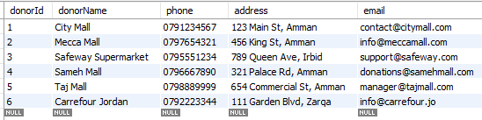
Donor:

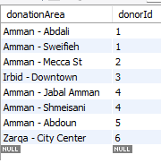
DonationAreas:

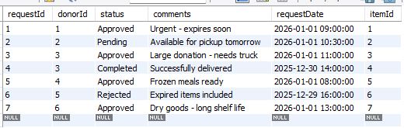
DonationRequest:

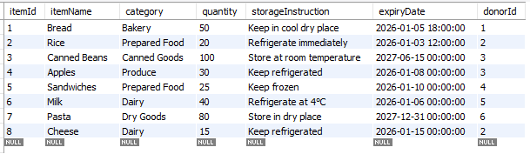
FoodItem:
Recipient: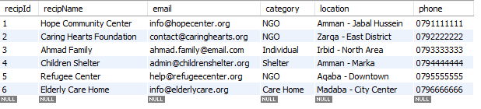
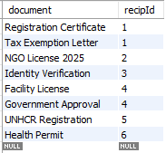
Documents:

Volunteer: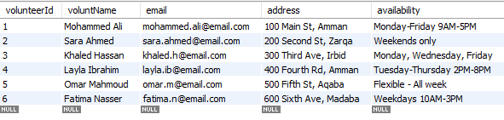

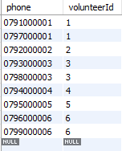
Phones:

DeliveryRecord:
